Exercise 1: Setting Up JUnit

package com.example;

import org.junit.Test;

import static org.junit.Assert.\*;

public class CalculatorTest {

@Test

public void testAddition() {

int result = 2 + 3;

assertEquals(5, result);

}

}

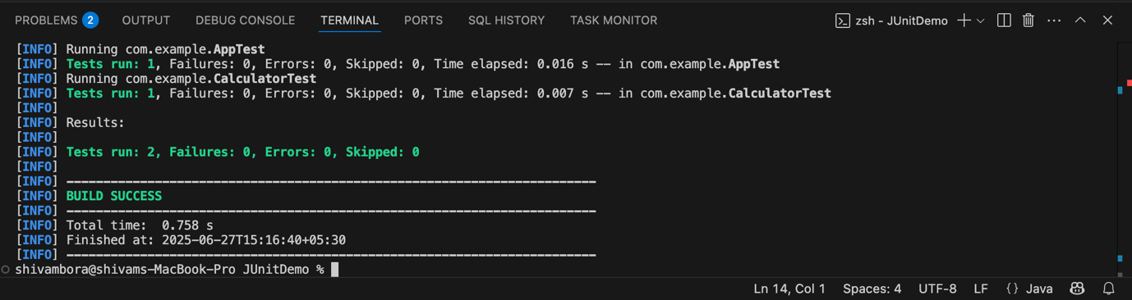

Exercise 3: Assertions in JUnit

Scenario:

You need to use different assertions in JUnit to validate your test results

package com.example;

import org.junit.Test;

import static org.junit.Assert.\*;

public class AssertionsTest {

@Test

public void testAssertions() {

// Assert equals

assertEquals(5, 2 + 3);

System.out.println("assertEquals passed");

// Assert true

assertTrue(5 > 3);

System.out.println("assertTrue passed");

// Assert false

assertFalse(5 < 3);

System.out.println("assertFalse passed");

// Assert null

assertNull(null);

System.out.println("assertNull passed");

// Assert not null

assertNotNull(new Object());

System.out.println("assertNotNull passed");

}

}

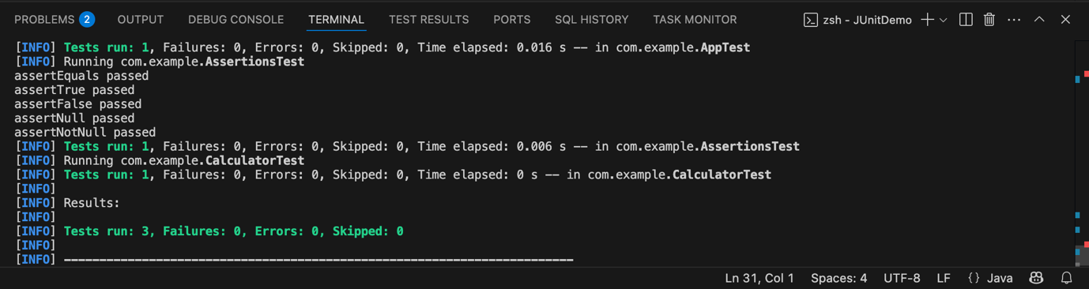

Exercise 4: Arrange-Act-Assert (AAA) Pattern, Test Fixtures, Setup and

Teardown Methods in JUnit

Scenario:

You need to organize your tests using the Arrange-Act-Assert (AAA) pattern and use setup

and teardown methods.

package com.example;

import org.junit.Before;

import org.junit.After;

import org.junit.Test;

import static org.junit.Assert.\*;

public class CalculatorTest {

private Calculator calc;

@Before

public void setUp() {

// Arrange: setup test fixture

calc = new Calculator();

System.out.println("setup called");

}

@After

public void tearDown() {

// Clean up resources if needed

calc = null;

System.out.println("teardown called");

}

@Test

public void testAdd() {

// Arrange

int a = 2;

int b = 3;

// Act

int result = calc.add(a, b);

// Assert

assertEquals(5, result);

System.out.println("assertEquals passed");

}

@Test

public void testSubtract() {

// Arrange

int a = 5;

int b = 2;

// Act

int result = calc.subtract(a, b);

// Assert

assertEquals(3, result);

System.out.println("assertEquals passed");

}

}

